Part A
Name:- Parva Gaglani
Roll No:- C172
Subject:- Data Structures and Algorithms
Program: B Tech/MBA Tech CE 2nd Year
Aim:
Implementation of Graph Traversal: Breadth first search, Depth first search
Prerequisite: C++ Programming
Outcome: Implementation of Graph Traversal: Breadth first search, Depth first search
- Theory:

- A graph G is defined as follows:
G=(V,E)
V(G): a finite, nonempty set of vertices
E(G): a set of edges (pairs of vertices)
Adjacency matrix representation
- An adjacency matrix is used to represent which nodes are adjacent to one another
- For any graph G having n nodes, the adjacency matrix will have the dimension of n * n.
- In an adjacency matrix, the rows and columns are labelled by graph vertices. An entry aij in the adjacency matrix will contain 1, if vertices vi and vj are adjacent to each other.

Graph Traversal
- Traversing a graph is visiting each nodes exactly once in a particular order.
- The two standard methods of graph traversal methods are-
- 1. Breadth-first search
- 2. Depth-first search
Algorithm – BFS
Step 1. Select the root node.
Step 2. Mark all nodes unvisited.
for (i=0; i<n; i++) visited[i]=0;
Step 3. Insert root node into the queue
insert(queue, root)
Step 4. while (queue not empty)
{
u= delete(queue)
If (u is not visited)
{
Mark u as visited, visited[u]=1
Print u;
Insert all adjacent nodes of u that are not visited.
}
}
Algorithm – DFS
Step 1. Select the root node.
Step 2. Mark all nodes unvisited.
for (i=0; i<n; i++) visited[i]=0;
Step 3. Insert root node into the queue
push(stack, root)
Step 4. while (stack not empty)
{
u= pop(stack)
If (u is not visited)
{
Mark u as visited, visited[u]=1
Print u;
push all adjacent nodes of u that are not visited.
}
}
Task:
Implement graph using adjacency matric and show traversal: BFS, DFS.
Procedure:
- Open CodeBlock editor or visual studio editor and write the code in C++.
- Complile and run the code
Instructions:

- Copy code & paste in code section and output of Part B.

Part B
Code:
#include <iostream>
using namespace std;

const int MAX_N = 100;

int adj_matrix[MAX_N][MAX_N];
int n; // number of nodes

// Initialize adjacency matrix
void initialize(int n) {
for (int i = 0; i < n; i++)
for (int j = 0; j < n; j++)
adj_matrix[i][j] = 0;
}

// Add edge
void add_edge() {
int u, v;
cout << "Enter edge to add (two nodes between 1 and " << n << "): ";
cin >> u >> v;
if (u >= 1 && u <= n && v >= 1 && v <= n) {
if (adj_matrix[u - 1][v - 1] == 1) {
cout << "Edge already exists between nodes " << u << " and " << v << "." << endl;
} else {
adj_matrix[u - 1][v - 1] = 1;
adj_matrix[v - 1][u - 1] = 1;
cout << "Edge added between nodes " << u << " and " << v << "." << endl;
}
} else {
cout << "Invalid input! Nodes must be between 1 and " << n << "." << endl;
}
}

// Remove edge
void remove_edge() {
int u, v;
cout << "Enter edge to remove (two nodes between 1 and " << n << "): ";
cin >> u >> v;
if (u >= 1 && u <= n && v >= 1 && v <= n) {
if (adj_matrix[u - 1][v - 1] == 1) {
adj_matrix[u - 1][v - 1] = 0;
adj_matrix[v - 1][u - 1] = 0;
cout << "Edge removed between nodes " << u << " and " << v << "." << endl;
} else {
cout << "No such edge exists between nodes " << u << " and " << v << "." << endl;
}
} else {
cout << "Invalid input! Nodes must be between 1 and " << n << "." << endl;
}
}

// Print adjacency matrix
void print_matrix() {
cout << "\nAdjacency Matrix for the Graph:" << endl;
for (int i = 0; i < n; i++) {
for (int j = 0; j < n; j++) {
cout << adj_matrix[i][j] << " ";
}
cout << endl;
}
}

// BFS Traversal
void BFS(int start) {
int visited[MAX_N] = {0};
int queue[MAX_N], front = 0, rear = 0;

visited[start] = 1; // Mark when inserting
queue[rear++] = start;

cout << "BFS Traversal starting from node " << start + 1 << ": ";

while (front < rear) {
int u = queue[front++];
cout << (u + 1) << " ";

for (int v = 0; v < n; v++) {
if (adj_matrix[u][v] == 1 && !visited[v]) {
visited[v] = 1; // Mark immediately
queue[rear++] = v;
}
}
}
cout << endl;
}

// DFS Traversal (iterative using stack)
void DFS(int start) {
int visited[MAX_N] = {0};
int stack[MAX_N], top = -1;

visited[start] = 1; // Mark when inserting
stack[++top] = start;

cout << "DFS Traversal starting from node " << start + 1 << ": ";

while (top >= 0) {
int u = stack[top--];
cout << (u + 1) << " ";

// Push neighbors in reverse order for natural order traversal
for (int v = n - 1; v >= 0; v--) {
if (adj_matrix[u][v] == 1 && !visited[v]) {
visited[v] = 1; // Mark immediately
stack[++top] = v;
}
}
}
cout << endl;
}

int main() {
int e;

cout << "Enter number of nodes (1 to 100): ";
cin >> n;
if (n < 1 || n > MAX_N) {
cout << "Invalid number of nodes! Must be between 1 and 100." << endl;
return 1;
}

initialize(n);

cout << "Enter number of edges initially: ";
cin >> e;
if (e < 0 || e > (n * (n - 1)) / 2) {
cout << "Invalid number of edges!" << endl;
return 1;
}

for (int i = 0; i < e; i++) {
add_edge();
}

int choice;
do {
cout << "\nMenu:\n";
cout << "1. Add Edge\n";
cout << "2. Remove Edge\n";
cout << "3. Print Adjacency Matrix\n";
cout << "4. BFS Traversal\n";
cout << "5. DFS Traversal\n";
cout << "6. Exit\n";
cout << "Enter your choice: ";
cin >> choice;

switch (choice) {
case 1:
add_edge();
break;
case 2:
remove_edge();
break;
case 3:
print_matrix();
break;
case 4: {
int start;
cout << "Enter starting node (1 to " << n << "): ";
cin >> start;
if (start >= 1 && start <= n)
BFS(start - 1);
else
cout << "Invalid starting node!" << endl;
break;
}
case 5: {
int start;
cout << "Enter starting node (1 to " << n << "): ";
cin >> start;
if (start >= 1 && start <= n)
DFS(start - 1);
else
cout << "Invalid starting node!" << endl;
break;
}
case 6:
cout << "Exiting program." << endl;
break;
default:
cout << "Invalid choice! Please select from the menu." << endl;
}

} while (choice != 6);

return 0;
}

Output:
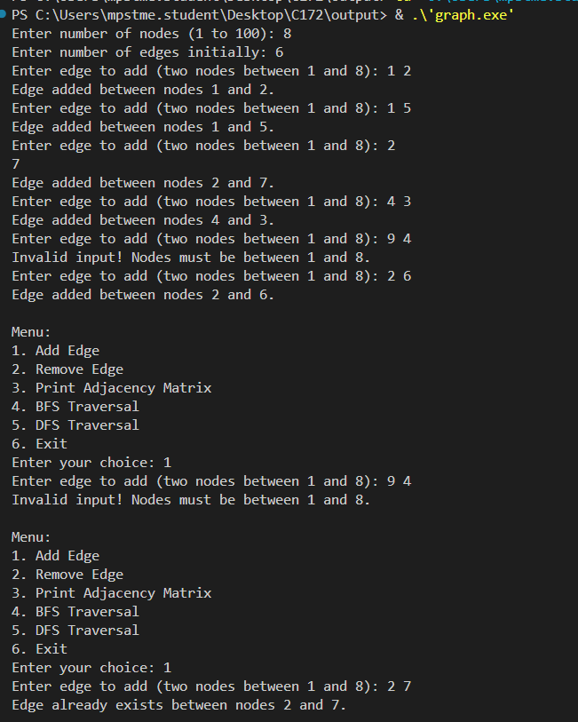
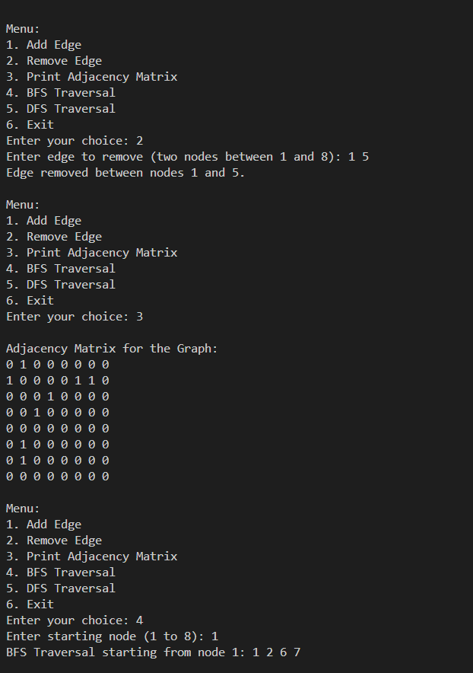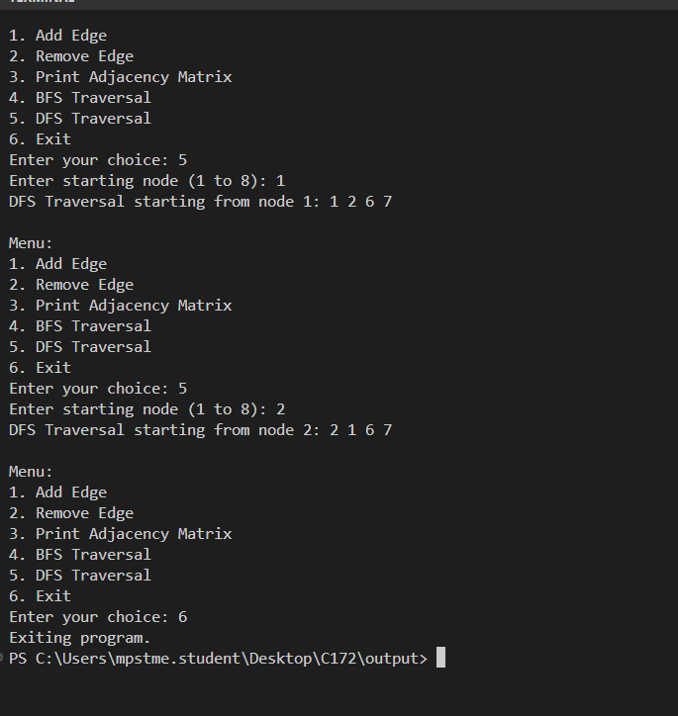
Observation & Learning:
Write your Observations & Learning after performing task
Curiosity questions:
- Write BFS and DFS traversal for the given graph
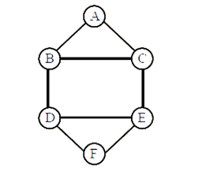
- BFS Traversal: A → B → C → D → E → F
- DFS Traversal: A → B → C → E → D → F

Conclusion:
We successfully implemented Graph Traversal: Breadth first search, Depth first search

